SAMPLE PARK CHAMPION™ EVENT INVITATION
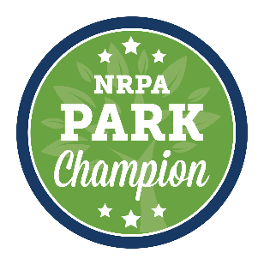
*Edit this invitation, then copy and paste it into the body of your email. Use the spreadsheet of schedulers in the Park Champion™ Advocacy Toolkit to find the appropriate contacts*
TO: Scheduler [firstname.lastname@mail.house.gov] or [first.lastname@membername.senate.gov]
SUBJECT: [Event Invitation]
BODY: Dear [Scheduler name],
Hello, my name is [Your name], and I am the [Your title] for [Your agency or organization]. [Your agency] is excited to be hosting [Event title] on [Event date and time]. [Describe the event you would like the member of Congress to attend. If the event date is flexible, keep in mind that the member will most likely be able to attend when Congress is in not in session.] [Your agency] would like to invite [Congressman/Congresswoman or Senator X] to attend this event.
[Add additional details about the event, including the names of other elected officials that are scheduled to attend, as well as opportunities for the member of Congress to participate in the event. Also consider referencing NRPA’s recent report with George Mason University, “The Economic Impact of Local Parks,” which found that America’s local and regional public park agencies generate $154 billion in economic activity and supports 1.1 million jobs every year.]
[Your agency name] is excited to show [Congressman/Congresswoman or Senator X] how parks and recreation make our community a wonderful place to live and how federal policy can support local parks and recreation.
Thank you for your service to the [Your city name] community and for your consideration of this invitation. Please contact me with questions and to discuss the details of the event.
Sincerely,
[Your Name]
[Your Title]
[Your email and phone number]

